118 FROM DECIMAL TO BINARY

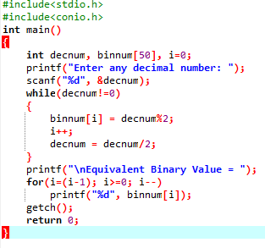

OUTPUT

